REPORT SERIES IN AEROSOL SCIENCE
N:o XXX (YYYY)

TITLE OF THE THESIS

FIRSTNAME LASTNAME

Institute for Atmospheric and Earth System Research / Physics
Department of Physics
Faculty of Science
University of Helsinki
Helsinki, Finland

Doctoral dissertation, to be presented for public discussion with the permission of the
Faculty of XX of the University of Helsinki, in Auditorium XX, Building name, on
the DDth of Month, YYYY at 12 o’clock.

Helsinki YYYY

Author’s Address: | Institute for Atmospheric and Earth System Research / Physics  P.O.Box 64  FI-00014 University of Helsinki  Firstname.lastname@helsinki.fi
Supervisors: | Professor Firstname Lastname, Ph.D.  Institute for Atmospheric and Earth System Research / Physics  University of Helsinki  Professor Firstname Lastname, Ph.D.  Institute for Atmospheric and Earth System Research / Physics  University of Helsinki
Reviewers: | Professor Firstname Lastname, Ph.D.  Department of XX  University of XX  Associate Professor Firstname Lastname, Ph.D.  Laboratory of XX  University of XX
Opponent: | Professor Firstname Lastname, Ph.D.  Institute of XX  University of XX
ISBN xxx-xxx-xxxx-xx-x (printed)
ISSN xxxx-xxxx
Helsinki YYYY
Unigrafia Oy
ISBN xxx-xxx-xxxx-xx-x (pdf)
ISSN xxxx-xxxx
Helsinki YYYY
https://www.FAAR.fi

Acknowledgements

Lorem ipsum dolor sit amet, consectetuer adipiscing elit. Ut purus elit, vestibulum
ut, placerat ac, adipiscing vitae, felis. Curabitur dictum gravida mauris. Nam arcu
libero, nonummy eget, consectetuer id, vulputate a, magna. Donec vehicula augue eu
neque. Pellentesque habitant morbi tristique senectus et netus et malesuada fames
ac turpis egestas. Mauris ut leo. Cras viverra metus rhoncus sem. Nulla et lectus
vestibulum urna fringilla ultrices. Phasellus eu tellus sit amet tortor gravida placerat.
Integer sapien est, iaculis in, pretium quis, viverra ac, nunc. Praesent eget sem vel leo
ultrices bibendum. Aenean faucibus. Morbi dolor nulla, malesuada eu, pulvinar at,
mollis ac, nulla. Curabitur auctor semper nulla. Donec varius orci eget risus. Duis
nibh mi, congue eu, accumsan eleifend, sagittis quis, diam. Duis eget orci sit amet orci
dignissim rutrum.

Firstname Lastname
Place, Month YYYY
Firstname Secondname Lastname
University of Helsinki, YYYY

Abstract

Lorem ipsum dolor sit amet, consectetuer adipiscing elit. Ut purus elit, vestibulum
ut, placerat ac, adipiscing vitae, felis. Curabitur dictum gravida mauris. Nam arcu
libero, nonummy eget, consectetuer id, vulputate a, magna. Donec vehicula augue eu
neque. Pellentesque habitant morbi tristique senectus et netus et malesuada fames
ac turpis egestas. Mauris ut leo. Cras viverra metus rhoncus sem. Nulla et lectus
vestibulum urna fringilla ultrices. Phasellus eu tellus sit amet tortor gravida placerat.
Integer sapien est, iaculis in, pretium quis, viverra ac, nunc. Praesent eget sem vel leo
ultrices bibendum. Aenean faucibus. Morbi dolor nulla, malesuada eu, pulvinar at,
mollis ac, nulla. Curabitur auctor semper nulla. Donec varius orci eget risus. Duis
nibh mi, congue eu, accumsan eleifend, sagittis quis, diam. Duis eget orci sit amet orci
dignissim rutrum.

Nam dui ligula, fringilla a, euismod sodales, sollicitudin vel, wisi. Morbi auctor lorem
non justo. Nam lacus libero, pretium at, lobortis vitae, ultricies et, tellus. Donec
aliquet, tortor sed accumsan bibendum, erat ligula aliquet magna, vitae ornare odio
metus a mi. Morbi ac orci et nisl hendrerit mollis. Suspendisse ut massa. Cras nec ante.
Pellentesque a nulla. Cum sociis natoque penatibus et magnis dis parturient montes,
nascetur ridiculus mus. Aliquam tincidunt urna. Nulla ullamcorper vestibulum turpis.
Pellentesque cursus luctus mauris.

Keywords: first keyword, second keyword, third keyword
Contents
1 Introduction 7
2 Materials and methods 8
2.1 Measurements 8
2.1.1 Field measurements 8
2.1.2 Laboratory measurements 9
2.2 Data analysis 9
3 Results and discussion 10
3.1 First result 10
3.2 Second result 10
3.3 Third result 11
4 Review of papers and the author’s contribution 12
5 Conclusions 13
References 14

List of publications

This thesis consists of an introductory review, followed by XX research articles. In the introductory part, the papers are cited according to their roman numerals.

- First, A., Second, A., Third, A., & Fourth, A. (2020). Title of paper one. Journal name, 1 (1), xxxx–xxxx. https://doi.org/xx.xxxx/xxx-xx-xxxx-xxxx
- First, A., Second, A., Third, A., & Fourth, A. (2021). Title of paper two. Journal name, 2 (2), xxxx–xxxx. https://doi.org/xx.xxxx/xxx-xx-xxxx-xxxx
- First, A., Second, A., Third, A., & Fourth, A. (2022b). Title of paper three. Journal name, 3 (3), xxxx–xxxx. https://doi.org/xx.xxxx/xxx-xx-xxxx-xxxx
- First, A., Second, A., Third, A., & Fourth, A. (2022a). Title of paper four. Journal name, 4 (4), xxxx–xxxx. https://doi.org/xx.xxxx/xxx-xx-xxxx-xxxx
- First, A., Second, A., Third, A., & Fourth, A. (2022a). Title of paper four. Journal name, 4 (4), xxxx–xxxx. https://doi.org/xx.xxxx/xxx-xx-xxxx-xxxx

[A statement about the permission to reprint can be given here, or prior to the re-print of each paper.]

Introduction
This is an example format of the introductory part of a PhD thesis used in the Institute of Atmosphere and Earth System Research. It produces similar format as the Latex template. Feel free to modify it according to your personal needs.

Note that the numbering starts from the very first page of the file but should be visible only from the beginning of Introduction (this page). Additionally, introduction should start from an odd page and if this is not the case add a blank page before the introduction.

Make sure that the Contents updates correctly. It should contain all chapters from Introduction forward as well as References.

Materials and methods

Measurements
Examples for references: Vehkamäki et al., 2012; Paper IV (there is no default reference management software, so that you can use whatever suits your needs)

Field measurements

Examples for equations
The Gibbs free energy is defined as
 | $G=U+P_{0}V-T_{0}S=H-T_{0}S$, | (2.1)
where U is the internal energy of the system, V is its volume, S is its entropy, and P₀ and T₀ are the pressure and temperature determined by the environment, respectively. Equations (as well as sections and figures etc.) can be referred to by inserting a cross-reference Eq. ( 2 .1).

Examples for figures
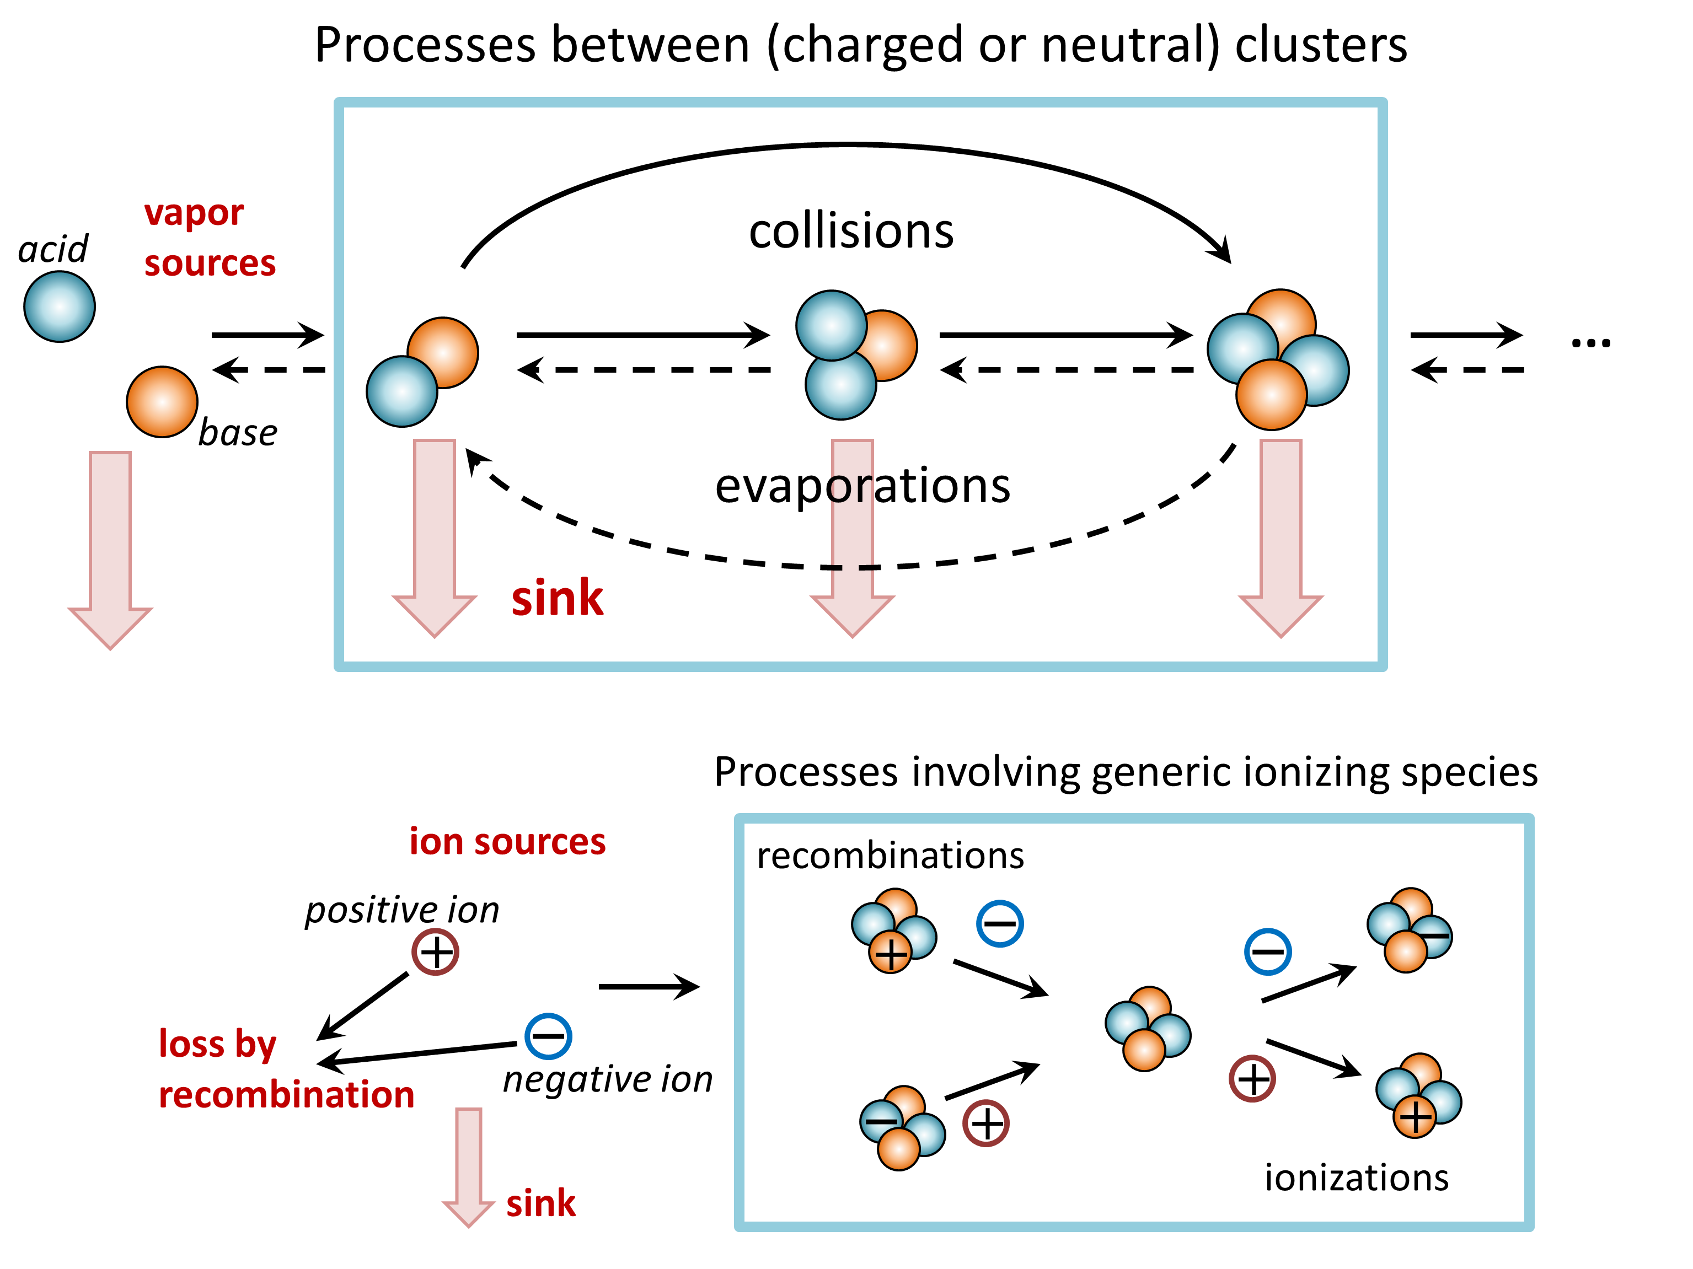
Figure 2: Processes included in the dynamic cluster population simulations. For figure clarity, the processes are presented for a two-component acid–base system, but the model can be applied to arbitrary one- or multicomponent systems.

Laboratory measurements
Nam dui ligula, fringilla a, euismod sodales, sollicitudin vel, wisi. Morbi auctor lorem
non justo. Nam lacus libero, pretium at, lobortis vitae, ultricies et, tellus. Donec
aliquet, tortor sed accumsan bibendum, erat ligula aliquet magna, vitae ornare odio
metus a mi. Morbi ac orci et nisl hendrerit mollis. Suspendisse ut massa. Cras nec ante.
Pellentesque a nulla. Cum sociis natoque penatibus et magnis dis parturient montes, nascetur ridiculus mus. Aliquam tincidunt urna. Nulla ullamcorper vestibulum turpis.
Pellentesque cursus luctus mauris

Data analysis
Nulla malesuada porttitor diam. Donec felis erat, congue non, volutpat at, tincidunt
tristique, libero. Vivamus viverra fermentum felis. Donec nonummy pellentesque ante.
Phasellus adipiscing semper elit. Proin fermentum massa ac quam. Sed diam turpis,
molestie vitae, placerat a, molestie nec, leo. Maecenas lacinia. Nam ipsum ligula,
eleifend at, accumsan nec, suscipit a, ipsum. Morbi blandit ligula feugiat magna.
Nunc eleifend consequat lorem. Sed lacinia nulla vitae enim. Pellentesque tincidunt
purus vel magna. Integer non enim. Praesent euismod nunc eu purus. Donec bibendum
quam in tellus. Nullam cursus pulvinar lectus. Donec et mi. Nam vulputate metus eu
enim. Vestibulum pellentesque felis eu massa.

Results and discussion
Lorem ipsum dolor sit amet, consectetuer adipiscing elit. Ut purus elit, vestibulum
ut, placerat ac, adipiscing vitae, felis. Curabitur dictum gravida mauris. Nam arcu
libero, nonummy eget, consectetuer id, vulputate a, magna. Donec vehicula augue eu
neque. Pellentesque habitant morbi tristique senectus et netus et malesuada fames
ac turpis egestas. Mauris ut leo. Cras viverra metus rhoncus sem. Nulla et lectus
vestibulum urna fringilla ultrices. Phasellus eu tellus sit amet tortor gravida placerat.
Integer sapien est, iaculis in, pretium quis, viverra ac, nunc. Praesent eget sem vel leo
ultrices bibendum. Aenean faucibus. Morbi dolor nulla, malesuada eu, pulvinar at,
mollis ac, nulla. Curabitur auctor semper nulla. Donec varius orci eget risus. Duis
nibh mi, congue eu, accumsan eleifend, sagittis quis, diam. Duis eget orci sit amet orci
dignissim rutrum

First result
Nam dui ligula, fringilla a, euismod sodales, sollicitudin vel, wisi. Morbi auctor lorem
non justo. Nam lacus libero, pretium at, lobortis vitae, ultricies et, tellus. Donec
aliquet, tortor sed accumsan bibendum, erat ligula aliquet magna, vitae ornare odio
metus a mi. Morbi ac orci et nisl hendrerit mollis. Suspendisse ut massa. Cras nec ante.
Pellentesque a nulla. Cum sociis natoque penatibus et magnis dis parturient montes, nascetur ridiculus mus. Aliquam tincidunt urna. Nulla ullamcorper vestibulum turpis.
Pellentesque cursus luctus mauris

Second result
Nulla malesuada porttitor diam. Donec felis erat, congue non, volutpat at, tincidunt
tristique, libero. Vivamus viverra fermentum felis. Donec nonummy pellentesque ante.
Phasellus adipiscing semper elit. Proin fermentum massa ac quam. Sed diam turpis,
molestie vitae, placerat a, molestie nec, leo. Maecenas lacinia. Nam ipsum ligula,
eleifend at, accumsan nec, suscipit a, ipsum. Morbi blandit ligula feugiat magna.
Nunc eleifend consequat lorem. Sed lacinia nulla vitae enim. Pellentesque tincidunt
purus vel magna. Integer non enim. Praesent euismod nunc eu purus. Donec bibendum
quam in tellus. Nullam cursus pulvinar lectus. Donec et mi. Nam vulputate metus eu
enim. Vestibulum pellentesque felis eu massa.

Third result
Quisque ullamcorper placerat ipsum. Cras nibh. Morbi vel justo vitae lacus tincidunt
ultrices. Lorem ipsum dolor sit amet, consectetuer adipiscing elit. In hac habitasse
platea dictumst. Integer tempus convallis augue. Etiam facilisis. Nunc elementum
fermentum wisi. Aenean placerat. Ut imperdiet, enim sed gravida sollicitudin, felis
odio placerat quam, ac pulvinar elit purus eget enim. Nunc vitae tortor. Proin tempus
nibh sit amet nisl. Vivamus quis tortor vitae risus porta vehicula

Review of papers and the author’s contribution
Paper I. Pellentesque interdum sapien sed nulla. Proin tincidunt. Aliquam volutpat
est vel massa. Sed dolor lacus, imperdiet non, ornare non, commodo eu, neque. Integer
pretium semper justo. Proin risus. Nullam id quam. Nam neque. Duis vitae wisi
ullamcorper diam congue ultricies. Quisque ligula. Mauris vehicula.

Paper II. Pellentesque interdum sapien sed nulla. Proin tincidunt. Aliquam volutpat
est vel massa. Sed dolor lacus, imperdiet non, ornare non, commodo eu, neque. Integer
pretium semper justo. Proin risus. Nullam id quam. Nam neque. Duis vitae wisi
ullamcorper diam congue ultricies. Quisque ligula. Mauris vehicula

Paper III. Pellentesque interdum sapien sed nulla. Proin tincidunt. Aliquam volutpat
est vel massa. Sed dolor lacus, imperdiet non, ornare non, commodo eu, neque. Integer
pretium semper justo. Proin risus. Nullam id quam. Nam neque. Duis vitae wisi
ullamcorper diam congue ultricies. Quisque ligula. Mauris vehicula

Paper IV. Pellentesque interdum sapien sed nulla. Proin tincidunt. Aliquam volutpat
est vel massa. Sed dolor lacus, imperdiet non, ornare non, commodo eu, neque. Integer
pretium semper justo. Proin risus. Nullam id quam. Nam neque. Duis vitae wisi
ullamcorper diam congue ultricies. Quisque ligula. Mauris vehicula

Paper V. Pellentesque interdum sapien sed nulla. Proin tincidunt. Aliquam volutpat
est vel massa. Sed dolor lacus, imperdiet non, ornare non, commodo eu, neque. Integer
pretium semper justo. Proin risus. Nullam id quam. Nam neque. Duis vitae wisi
ullamcorper diam congue ultricies. Quisque ligula. Mauris vehicula

Conclusions
Fusce mauris. Vestibulum luctus nibh at lectus. Sed bibendum, nulla a faucibus sem-
per, leo velit ultricies tellus, ac venenatis arcu wisi vel nisl. Vestibulum diam. Aliquam
pellentesque, augue quis sagittis posuere, turpis lacus congue quam, in hendrerit risus
eros eget felis. Maecenas eget erat in sapien mattis porttitor. Vestibulum porttitor.
Nulla facilisi. Sed a turpis eu lacus commodo facilisis. Morbi fringilla, wisi in dignissim
interdum, justo lectus sagittis dui, et vehicula libero dui cursus dui. Mauris tempor
ligula sed lacus. Duis cursus enim ut augue. Cras ac magna. Cras nulla. Nulla egestas.
Curabitur a leo. Quisque egestas wisi eget nunc. Nam feugiat lacus vel est. Curabitur
consectetuer.

References

First, A., Second, A., Third, A., & Fourth, A. (2020). Title of paper one. Journal name, 1 (1), xxxx–xxxx. https://doi.org/xx.xxxx/xxx-xx-xxxx-xxxx
Ahlrichs, R., Bär, M., Häser, M., Horn, H., and Kölmel, C. (1989). Electronic structure calculations on workstation computers: The program system Turbomole. Chem. Phys. Lett., 162: 165-169.
Jensen, F. (2007). Introduction to Computational Chemistry. John Wiley & Sons Ltd., West Sussex, U.K.
Loukonen, V. (2014). Sulfuric acid and amines in atmospheric clustering: first-principles investigations. Academic dissertation. Report Series in Aerosol Science, 150, University of Helsinki.

